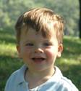  Mom’s Group Trading Cards: 2006  jacob  born: 12/10/04  inhales burritos  pulls hair  calls his dog “lucy-ruff-ruff”  Collect them all! | Mom’s Group Trading Cards: 2006 | Collect them all!  abby  born: 12/12/04  organizes group hugs  dances to “these boots were made for walking”  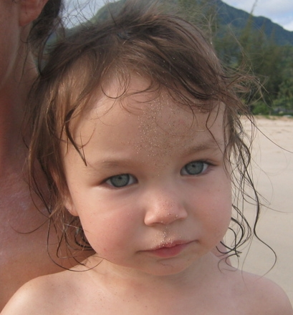
Mom’s Group Trading Cards: 2006  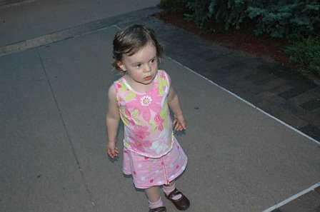  emma  born: 12/04/04  hangs with doll “Lily”  way into stickers  Collect them all! | Mom’s Group Trading Cards: 2006 | Collect them all!  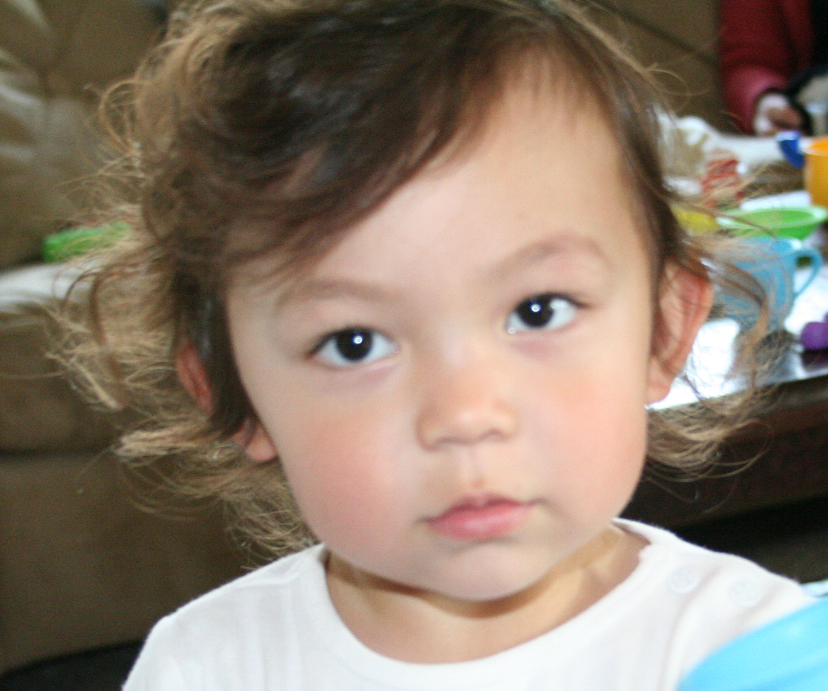  jane  born: 12/01/04  calls herself “bubby”  obsessed with monkeys

